**RYAN SPORT CLUB**

**Documentation**

|  |  |  |
| --- | --- | --- |
| **Faculty** | **Miss Neelam Malik** | |
| **Batch** | **2209C1** | |
| **Group** | **B** | |
| **Serial No.** | **Enrollment Number** | **Student Name** |
| 1. | Student1418272 | MUHAMMAD HASEEB |
| 2. | Student1417834 | HAMZA SIDDIQUI |
| 3. | Student1414888 | MUHAMMAD SARIB |
| 4. | Student1414765 | MUHAMMAD SAIF ULLAH |

**TABLE OF CONTENT:**

Documentation ---------------------------------------------------------------- 1

Acknowledgement ------------------------------------------------------------ 3

Certification -------------------------------------------------------------------- 4

Problem Statement ------------------------------------------------------------- 5

Sitemap -------------------------------------------------------------------------- 7

Screen Shots --------------------------------------------------------------------- 8

Task Sheet Review 2 --------------------------------------------------------- 13

Task Sheet Review 3 ----------------------------------------------------------14

**ACKNOWLEDGEMENT**

We are thankful to Almighty, ALLAH that by His grace we have been successful. we presenting on Dream Weaver in your hands. We have tried our best to take all relevant important topics in consideration so that this project may become comprehensive.

This is our First Year Semester E-project. We have tried our best & struggled for a better outlook to come. This project has been developed in Dream Weaver. We choose to make Webpage for Garden World.com as a project. We find easy to do coding in Dream Weaver.

We earnestly hope that this project will provide all the necessarily information required for the user to fulfill their inspiration. However, suggestions for improvement of the project will be thankful received & acknowledge.

**THANKING YOU……**

**CERTIFICATION:**

This is to certify that

HAMZA SIDDIQUI

MUHAMMAD HASEEB

MUHAMMAD SARIB, MUHAMMAD SAIF ULLAH

Have successfully designed, develop and submitted the Festivals website.

**Problem Statement**

RYAN Sports Club, an effort has been made to provide a world class facilities and infrastructure for the promotion of sports and health. During the past time, RYAN sports club has emerged as one of the best facilities in the country in the area of sports and health and also it is making strides to acquire a formidable presence in the international. The club provides the facilities like “Indoor Sports”, Outdoor Sports” and “Recreation”. All this information is required to be presented in organized form for which a website is required to be created.

**Requirement Specification:**

The Web site is to be created based on the following requirements.

1. The Home Page with some description about the club with proper template designed. (Also navigational link must be included.)
2. The link facilities like “Indoor Sports”, Outdoor Sports” and “Recreation”.
3. Membership link must be added in the website. (a dummy form is supposed to be fill and submitted).
4. List of the activities arranged yearly.
5. Suggestion and complaints
6. Feedback
7. Contact Us
8. Information must be added for each type of sports played (like rules, images, information, some famous players and Timings so on)
9. List of the top of sports person can be added in the website.
10. Navigation facilities must be made précised in the application.
11. Picture gallery must be added in the application.

**Hardware/ Software Requirements**

**Hardware**

* A minimum computer system that will help you access all the tools in the courses is a Pentium 166 or better
* 64 Megabytes of RAM or better

**Software**

* Notepad/HTML editor
* Dreamweaver
* IE 5.0/ Netscape 6.0

**Sitemap:**

**Screenshots**

**Home page**

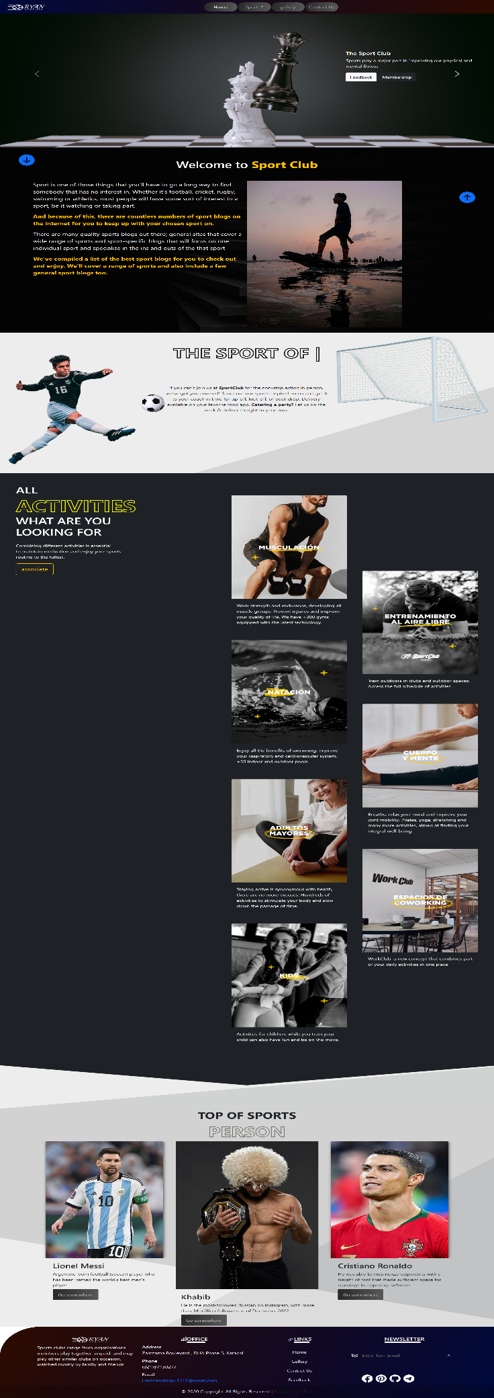

**Sports**

1. Indoor Sport
2. Outdoor Sport

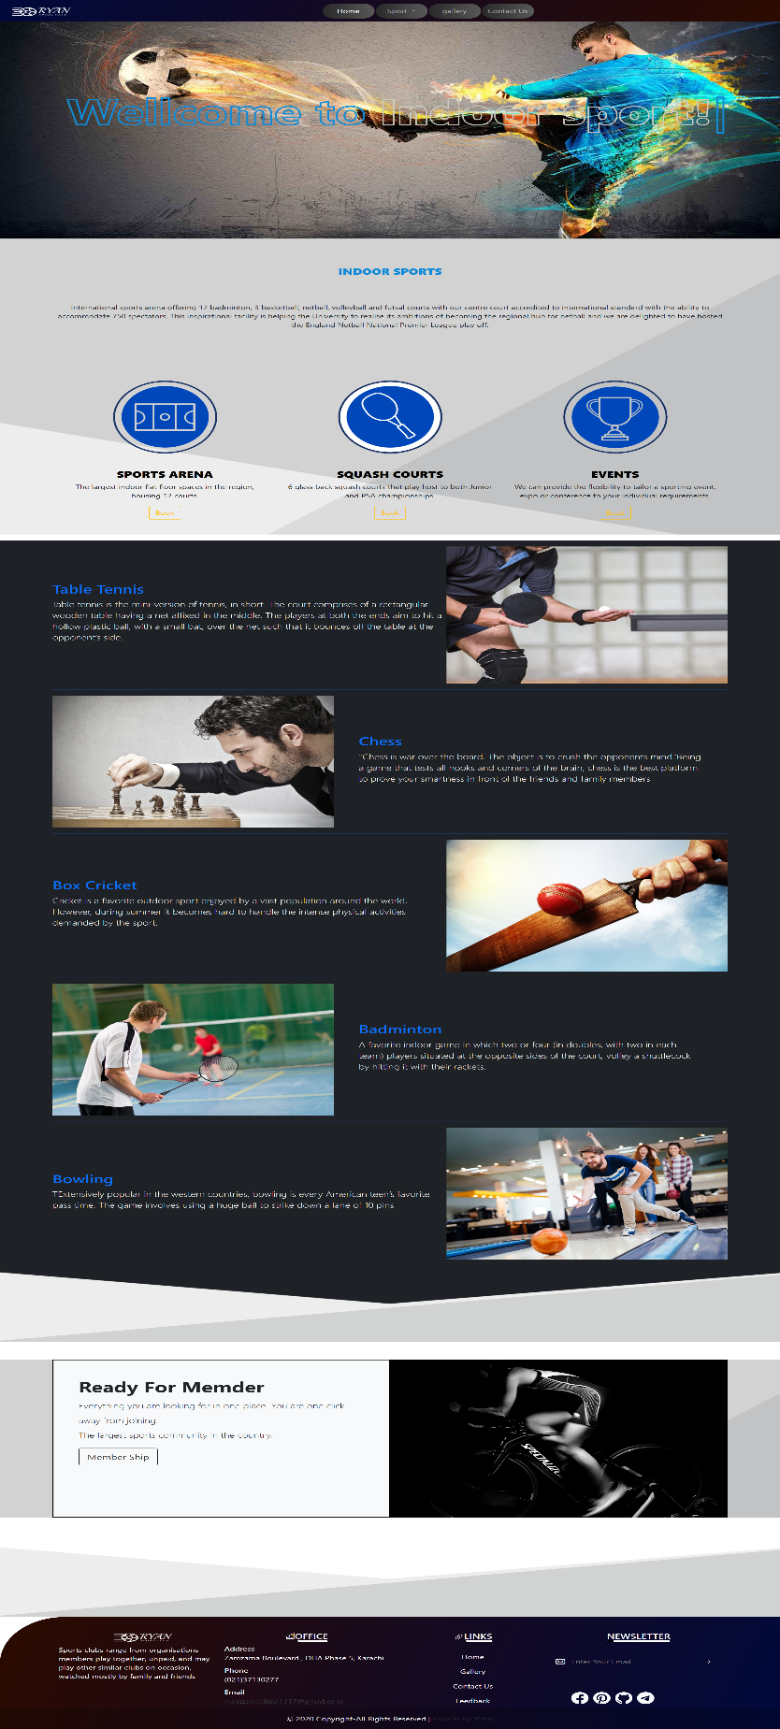**Indoor Sport**

**Outdoor Sport**

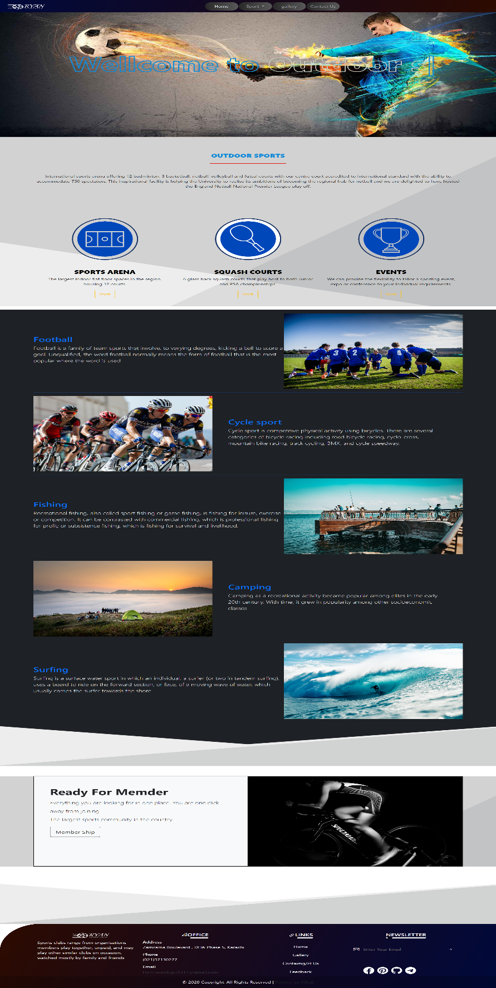

**Gallery**

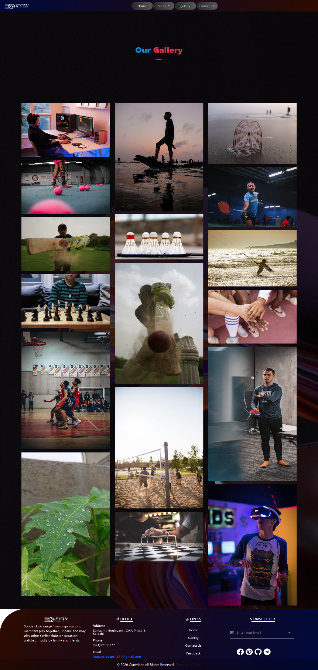

**Contact Us**

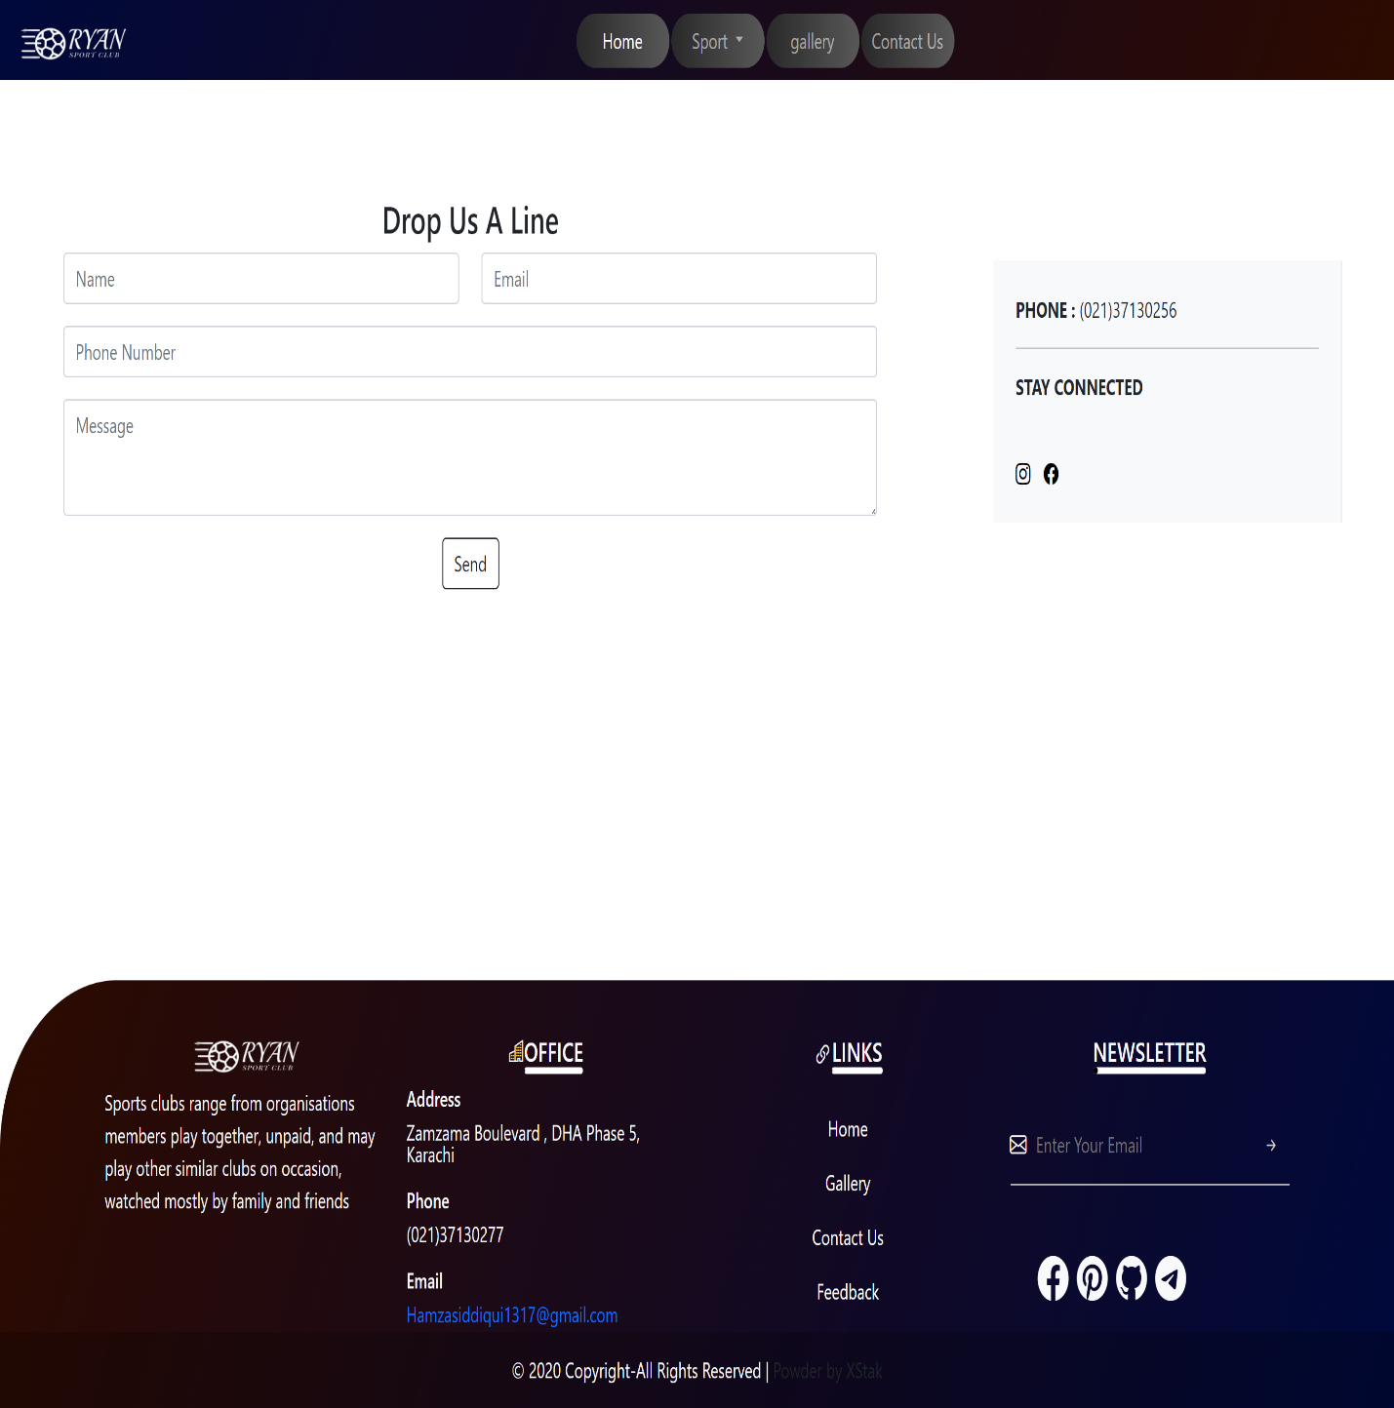

**Feedback**

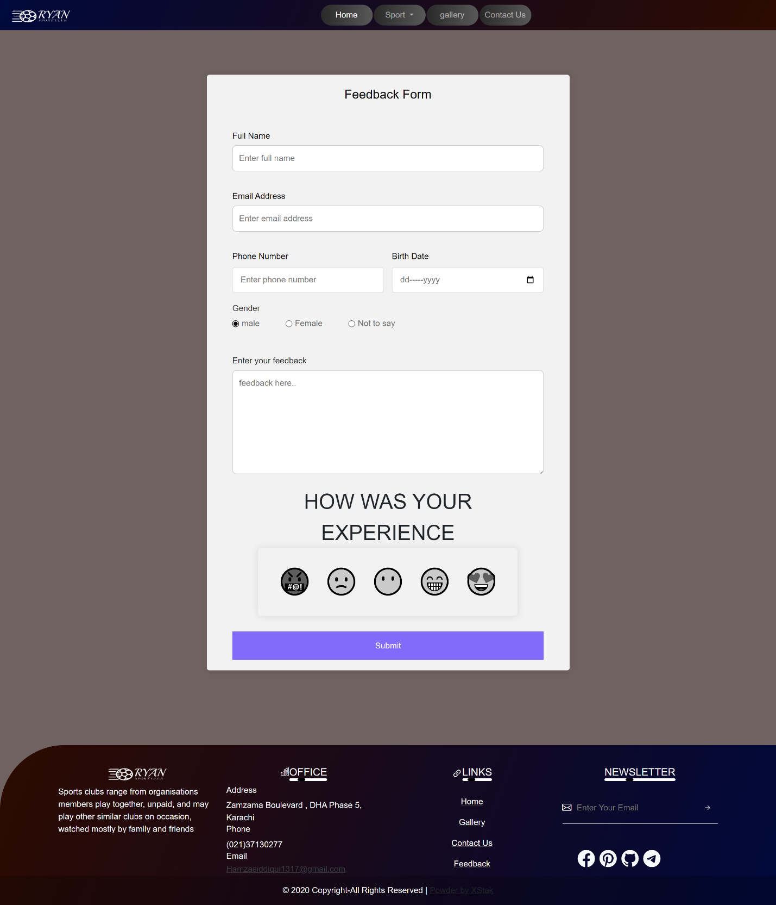

**Member Ship**

1. Monthly
2. Annual

**Monthly**

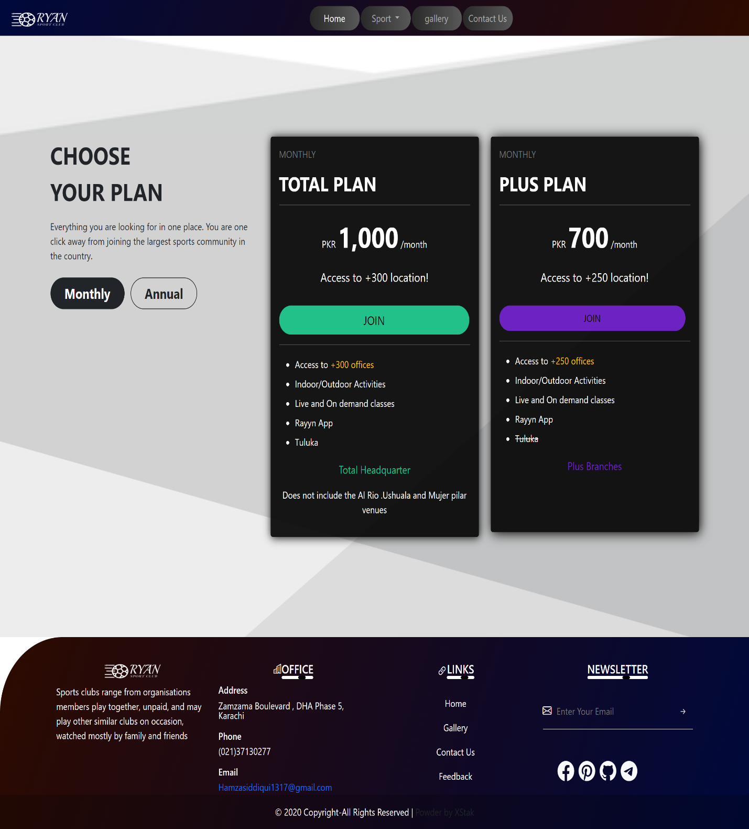

**Annual**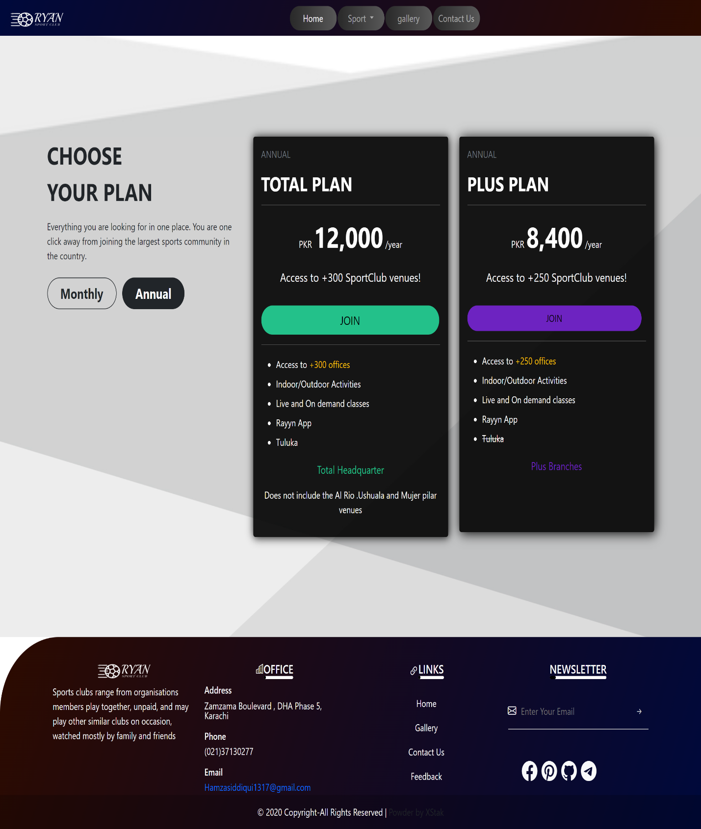

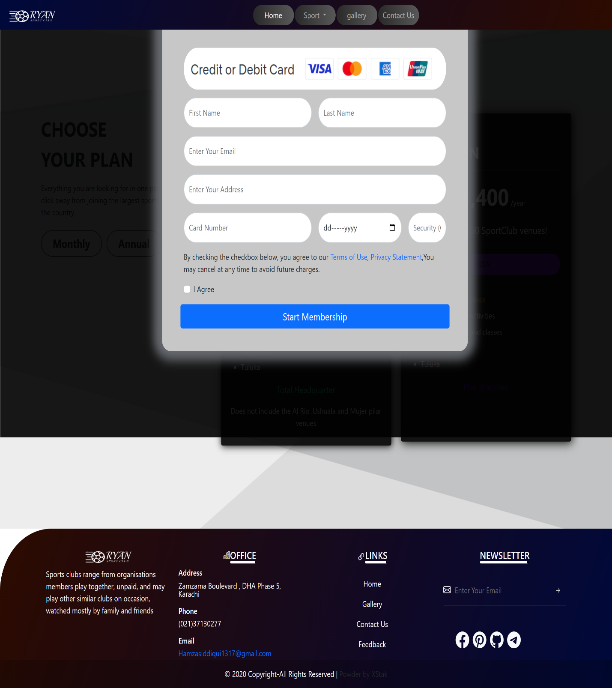

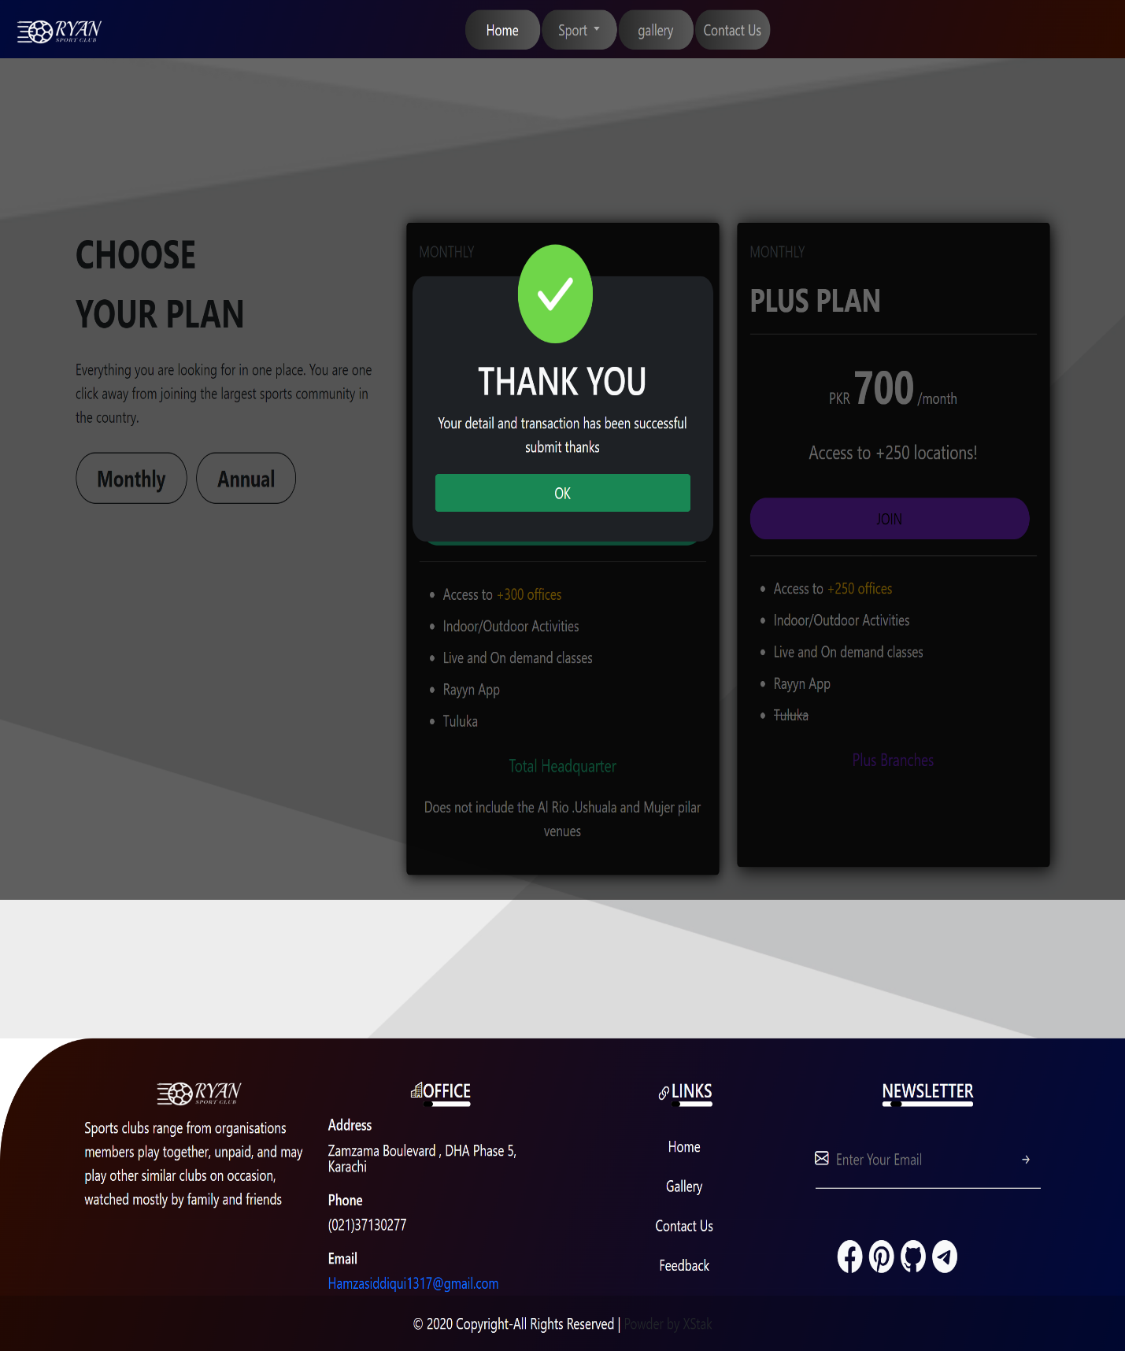

**TASK SHEET REVIEW 1**

|  |  |  |  |  |  |  |
| --- | --- | --- | --- | --- | --- | --- |
| Project Ref. No.: eP/Advertisement Portal Management System/01 | | Project  title | Date of Preparation of Activity Plan | | | |
| No | Task | RYYAN  SPORT CLUB | Actual | Actual | Team-mate | Status |
| Start Date | Days | Names |
| 1 | Navbar | 12/JAN/2023 | 1 | HAMZA SIDDIQUI | Complete |
| 2 | Main Body Navbar | 13/JAN/2023 | 1 | HAMZA SIDDIQUI | Complete |
| 3 | Footer | 15/JAN/2023 | 2 | HAMZA SIDDIQUI | Complete |
| 4 | **clone of Home page** | 17/JAN/2023 | 2 | HAMZA SIDDIQUI | Complete |
| 5 | Activity | 21/JAN/2023 | 4 | HAMZA SIDDIQUI | Complete |
| 6 | Indoor page | 24/JAN/2023 | 3 | HAMZA SIDDIQUI | Complete |
| 7 | Outdoor page | 26/JAN/2023 | 2 | HAMZA SIDDIQUI | Complete |
| 8 | Contact page | 28/JAN/2023 | 1 | HAMZA SIDDIQUI | Complete |

**TASK SHEET REVIEW 2**

|  |  |  |  |  |  |  |
| --- | --- | --- | --- | --- | --- | --- |
| Project Ref. No.: eP/Advertisement Portal Management System/01 | | Project title | Date of Preparation of Activity Plan | | | |
| No | Task | RYYAN  SPORT CLUB | Actual  Start Date | Actual  Days | Team-mate  Names | Status |
| 1 | Gallery | 30/JAN/23 | 2 | HAMZA SIDDIQUI | Complete |
| 2 | Member ship | 2/FAB/23 | 3 | HAMZA SIDDIQUI | Complete |
| 3 | Feedback | 4/FAB/23 | 2 | SARIB SALEEM | Complete |
| 4 | J query and JavaScript | 10/FAB/23 |  | HAMZA SIDDIQUI | Complete |